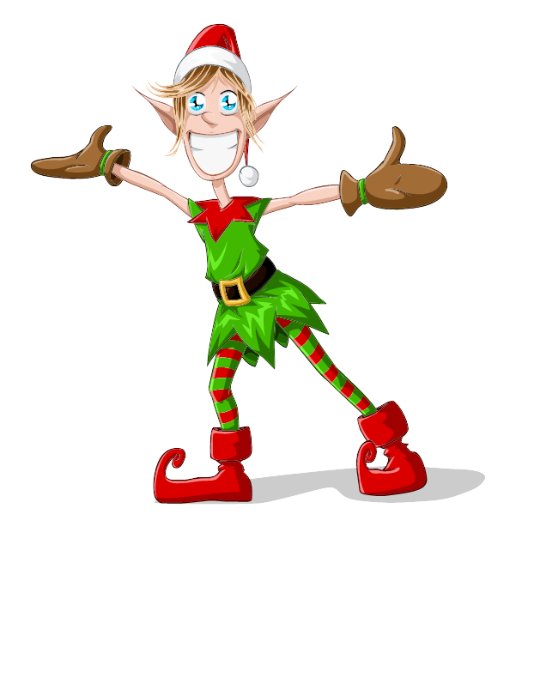
Doctor Wizard’s Giant Musical Holiday Light Show
Guestbook

Thank You for visiting my light show!
Please write your name(s) and any comments below. If you would like to receive a notification email about next year’s show, please include your email address.


Like, Follow, and Share us on Facebook!
https://facebook.com/wizlights
For a list of other great local light shows, visit our own website at
www.wizlights.com

